Part 1:

[Exercise 1: Changing the Dashboard Footer](http://holowczak.com/getting-started-with-pentaho-community-edition-dashboard-editor-cde/3/#exercise1) - Show a picture of your dashboard.

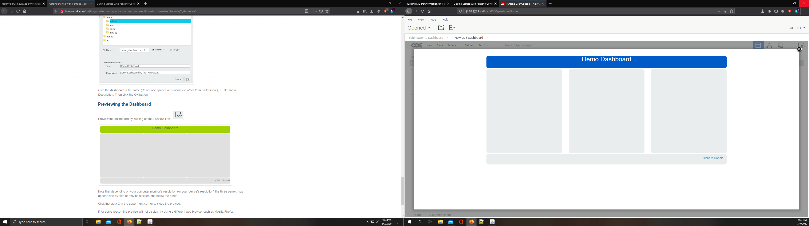

[Exercise 2: Creating a Table Display](http://holowczak.com/getting-started-with-pentaho-community-edition-dashboard-editor-cde/8/#exercise2) - Show a picture of your dashboard

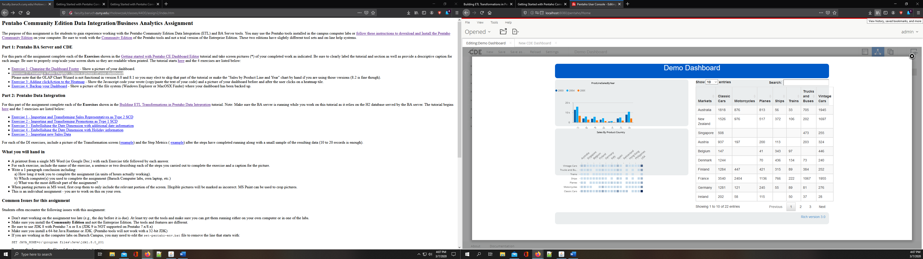

[Exercise 3: Adding clickAction to the Heatmap](http://holowczak.com/getting-started-with-pentaho-community-edition-dashboard-editor-cde/9/#exercise3) - Show the Javascript code your wrote (copy/paste the text of your code) and a picture of your dashboard before and after the user clicks on a heatmap tile.

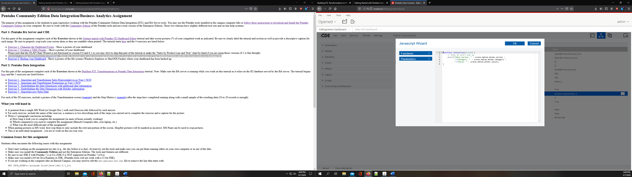

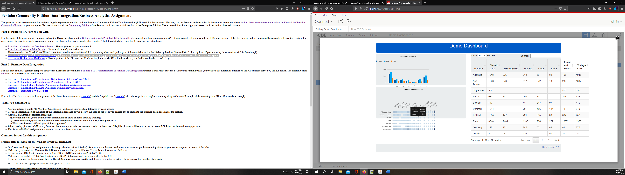

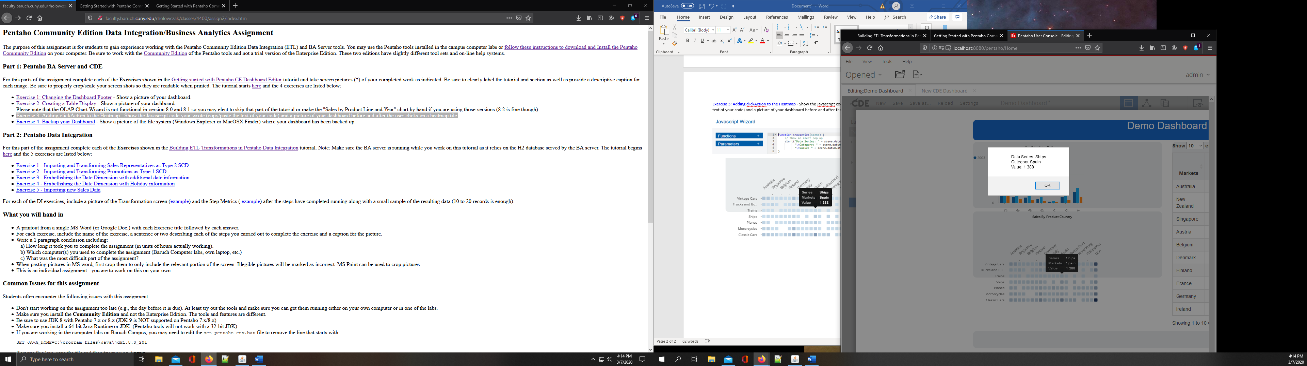

[Exercise 4: Backup your Dashboard](http://holowczak.com/getting-started-with-pentaho-community-edition-dashboard-editor-cde/10/#exercise4) - Show a picture of the file system (Windows Explorer or MacOSX Finder) where your dashboard has been backed up.

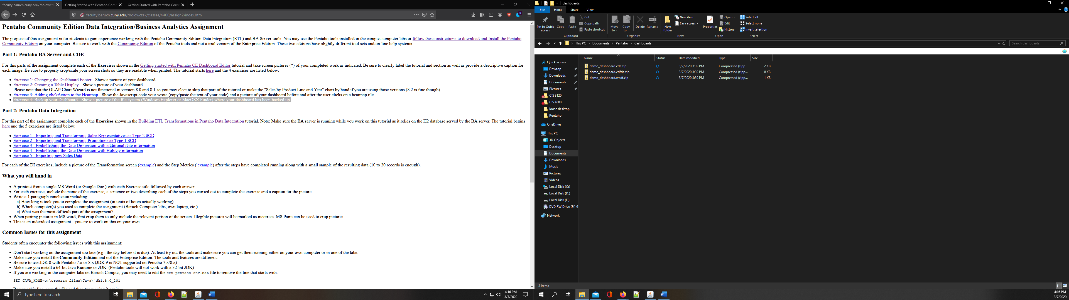

Part 2:

[Exercise 1 - Importing and Transforming Sales Representatives as Type 2 SCD](http://holowczak.com/building-etl-transformations-in-pentaho-data-integration-kettle/8/)

In this exercise I first uploaded the salesrep csv in in the file import. Then in the Dimension update I established a connection, a new target dimension named salesrep_dim and established a surrogate key for the new dimension. 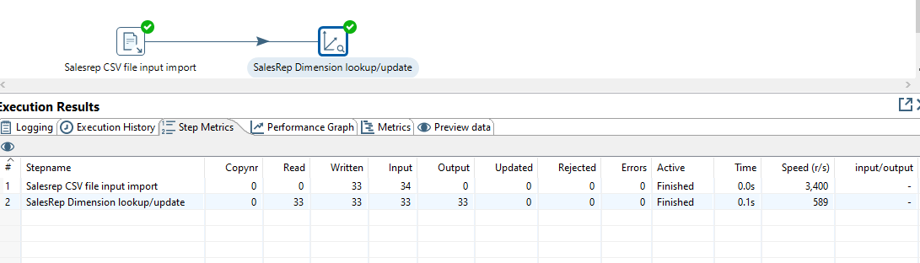

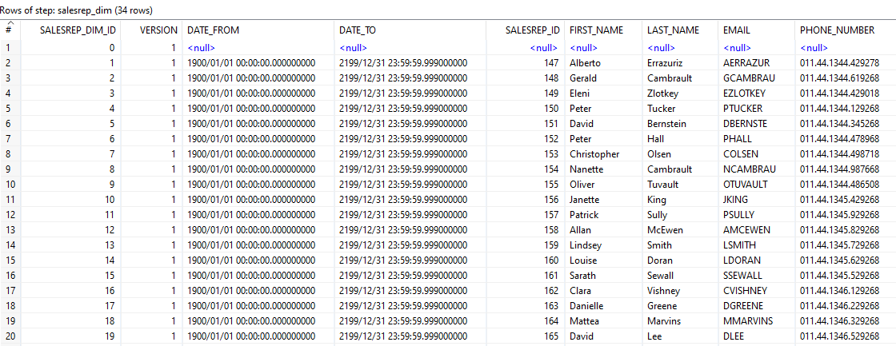

[Exercise 2 - Importing and Transforming Promotions as Type 1 SCD](http://holowczak.com/building-etl-transformations-in-pentaho-data-integration-kettle/10/)

In this exercise first I uploaded the promotion csv file and then in the Dimension lookup/update I indicated “punch through” as the type of dimension update in the Fields tab.

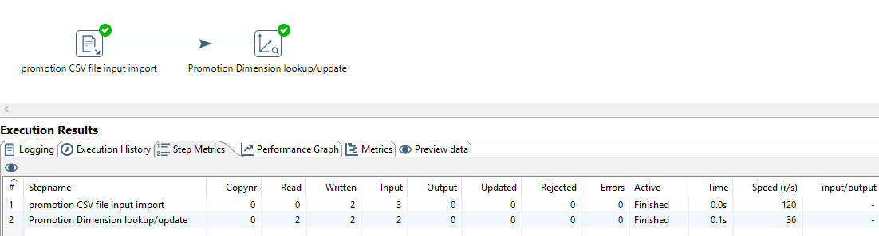

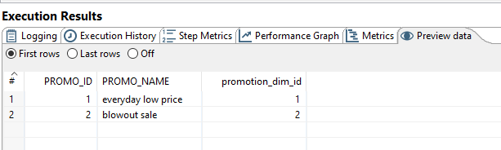

[Exercise 3 - Embellishing the Date Dimension with additional date information](http://holowczak.com/building-etl-transformations-in-pentaho-data-integration-kettle/12/)

In this exercise, first I created a table, by using a date sequence and a calculator to increment, which generated dates starting from 2016 for 1100 rows. Next, I created another calculator which calculated and created fields for days of the month, week, etc; which was all then loaded into a date dimension.

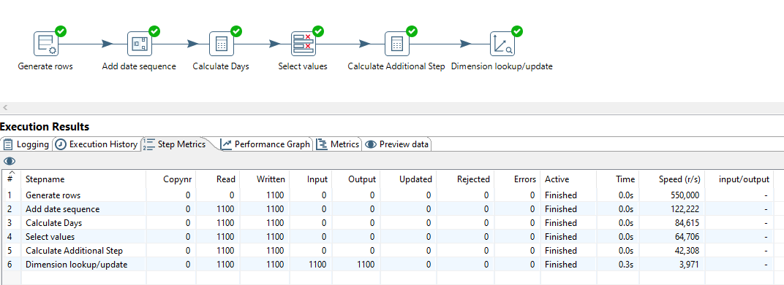

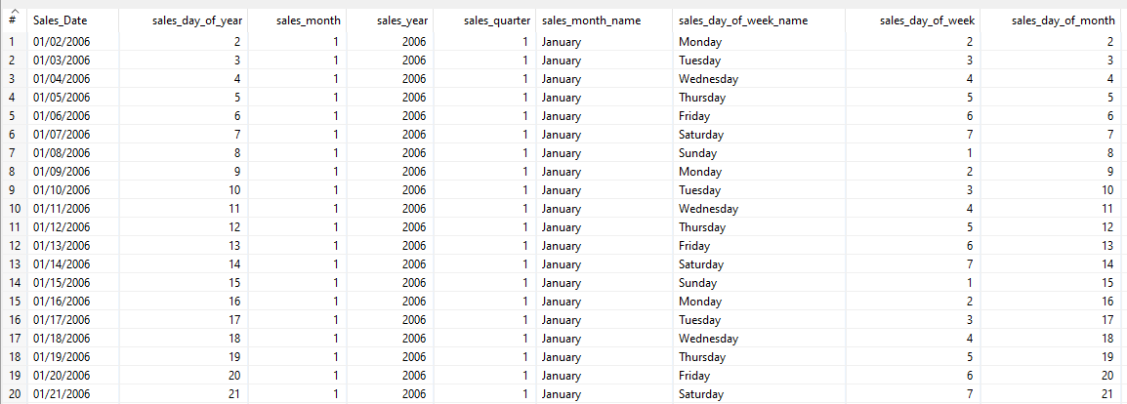

[Exercise 4 - Embellishing the Date Dimension with Holiday information](http://holowczak.com/building-etl-transformations-in-pentaho-data-integration-kettle/13/)

In this exercise continued to embellish the date dimension by uploading an Excell sheet containing holiday descriptions and added fields to the date dimension which identified whether that day was a holiday or not and what the holiday was.

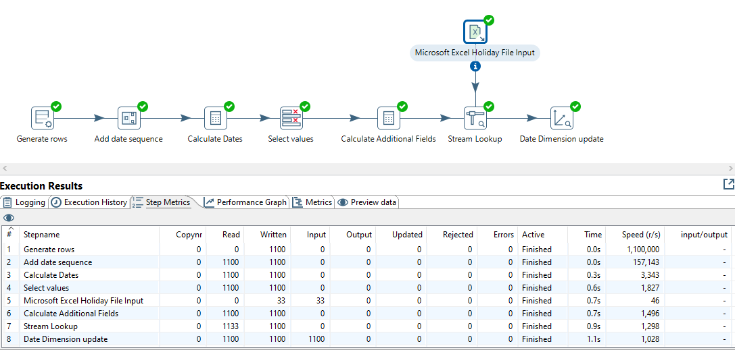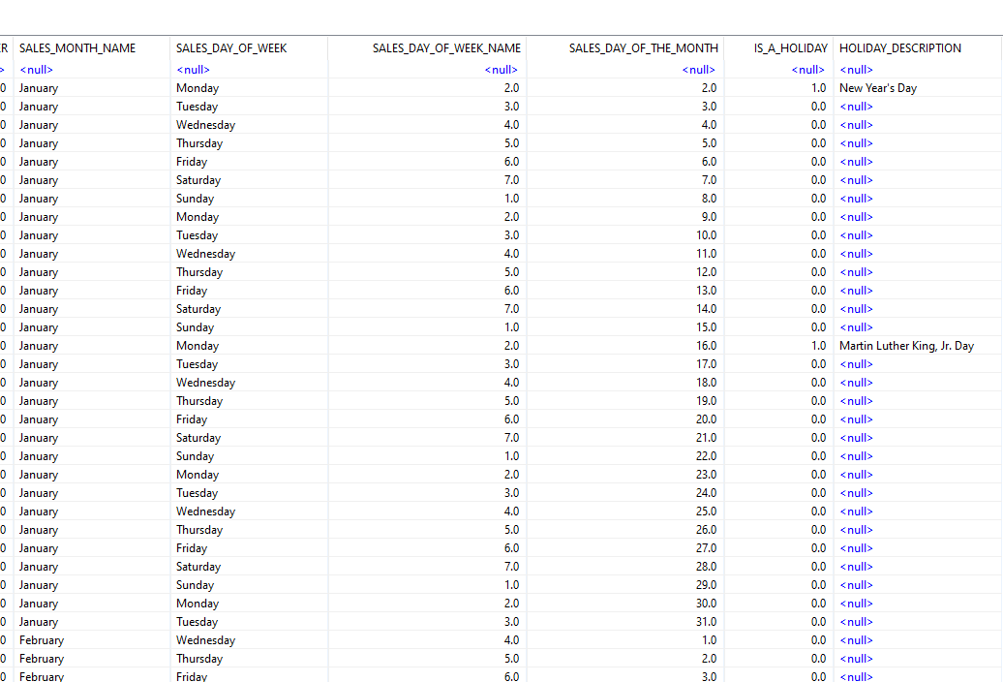

[Exercise 5 - Importing new Sales Data](http://holowczak.com/building-etl-transformations-in-pentaho-data-integration-kettle/15/)

In this exercise I created the Sales Fact Table. All the dimensions created in the previous steps are uploaded with source data from the orders_export_new.csv, then sales totals are calculated and loaded into the fact table.

